**Overview of SLO:** 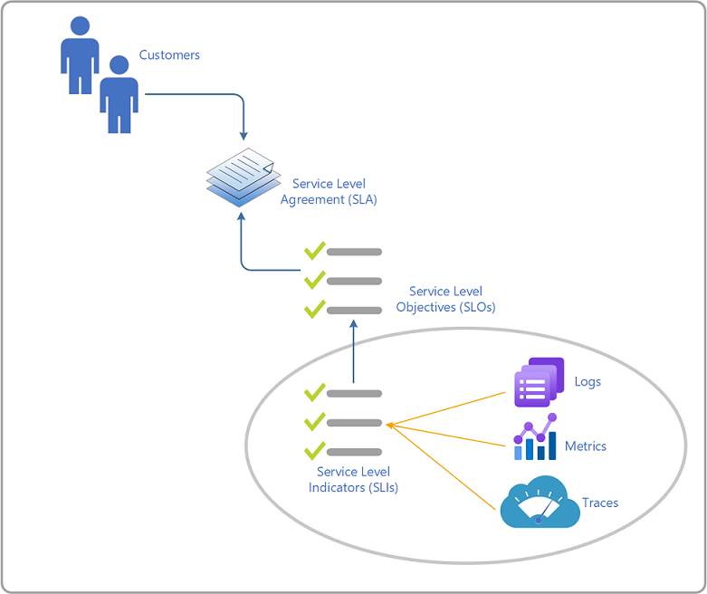

**SLI** - We recommend that you create no more than three indicators. More than three indicators rarely add significant value. Often, excessive numbers of indicators could mean you are including symptoms of primary indicators.

1 Traffic and saturation should be additional to those three main indicators, as those describe service load and support on interpretation of other service indicators.

**SLO** – the database - Requests in the last 5 minutes are served in under 10 milliseconds at the 99th percentile.

**Opensource Monitoring Tool:**

* Pensive – which we are using in Maersk.

*Note: If you have budget, then we can recommend to use Azure Monitor tool.*

*Azure Monitor is a software as a service (SaaS) offering, so its supporting infrastructure runs in Azure and is managed by Microsoft. It performs monitoring, analytics, and diagnostics at scale. It's available in all national clouds. Core parts of the infrastructure (collectors, metrics and logs store, and analytics) that support Azure Monitor are maintained by Microsoft.*

